**GANPAT UNIVERSITY**

**U. V. PATEL COLLEGE OF ENGINEERING**

**B.Tech CE/IT Semester IV**

**2CEIT404: Python Programming**

**Practical-3: Iterative Statements and Strings**

1. Write a program to check if number is Armstrong.

**Code:**

print("20012011130_Patel Vandan")

num=int(input("Enter Number:"))

sum=0

temp=num

*while*(num>0):

    num1 = num % 10

    sum = sum + num1 ** 3

    num = int(num / 10)

*if*(sum==temp):

    print(f"{temp} is an armstrong number.")

*else*:

    print(f"{temp} is an armstrong not number.")

**Output:**

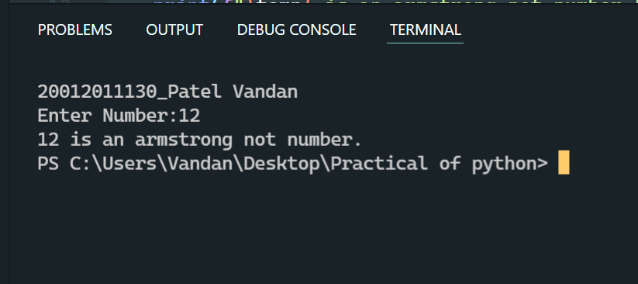

1. Write a program to check special number. (Number is equal to the sum of its divisors)

**Code:**

print("20012011130_Patel Vandan")

num =int(input("Enter Number:"))

sum=0

*for* i *in* range(1,num):

*if*(num % i == 0):

        sum = sum +i

*if*(num == sum):

    print(f"{num} is a special number")

*else*:

    print(f"{num} is a special not number")

**Output:**

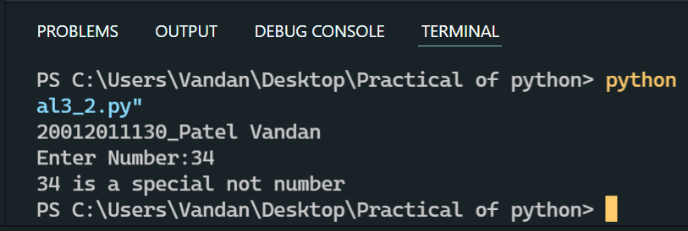

1. Create a program that will print out words that start with 's' from the below given statement.

st='Print only the words that start with s in this sentence'

**Code:**

print("20012011130_Pateel Vandan")

st='Print only the words that start with s in this sentence'

*for* i *in* st.split():

*if*(i[0] == 's'):

        print(i)

**Output:**

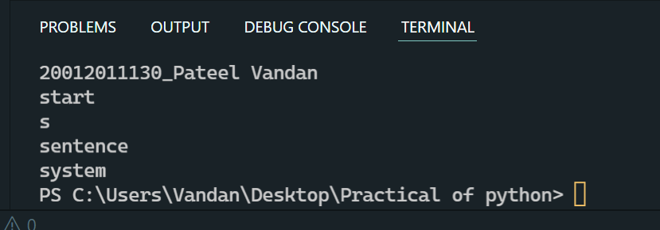

1. Write a program to give output of entered number multiplication table.

**Code:**

print("20012011130_Patel Vandan")

num = int(input("Enter a number: "))

sum = 0

*for* i *in* range(1,11):

    sum = num * i

    print(num , " * " , i , " = " , sum)

**Output:**

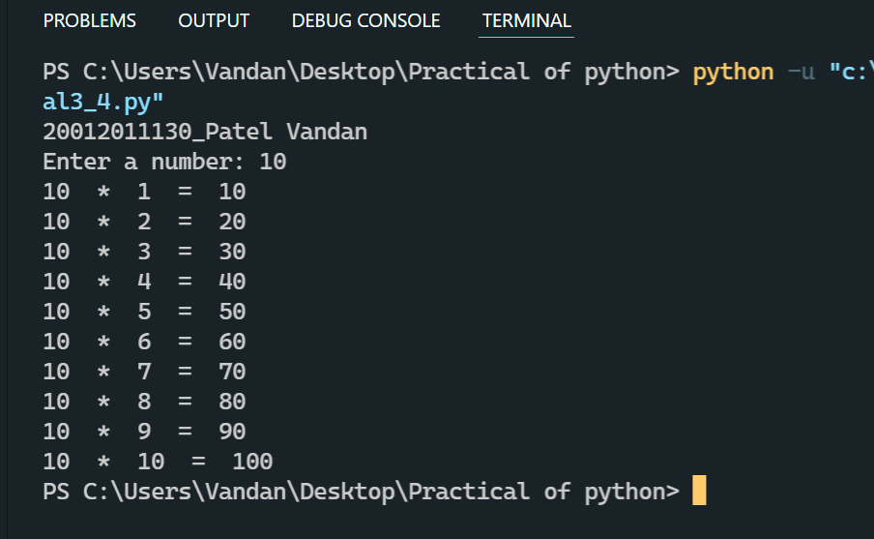

1. Write a program to find the sum of digit of an input number using while loop.

**Code:**

print("20012011130_Patel Vandan")

num=int(input("Enter Number:"))

sum=0

temp=num

*while*(num>0):

   num1=num%10

   sum=sum+num1

   num=int(num/10)

print(f"Sum of the given number {temp} is {sum}")

**Output:**

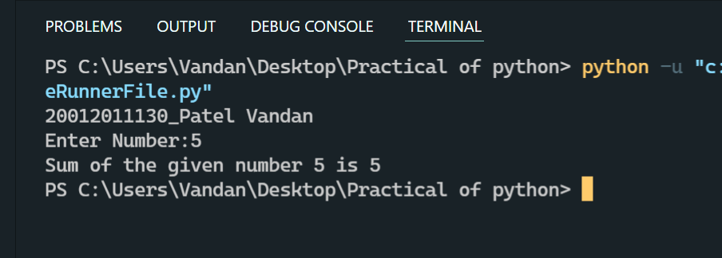

1. Go to String below and if the length of a word is even print "even!".

st='I love doing python programming in spyder'

**Code:**

print("20012011130_Patel Vandan")

st='I love doing python programming in spyder'

*for* i *in* (st.split()):

*if*(len(i) % 2 == 0):

        print(f"Length of word {i} is even")

**Output:**

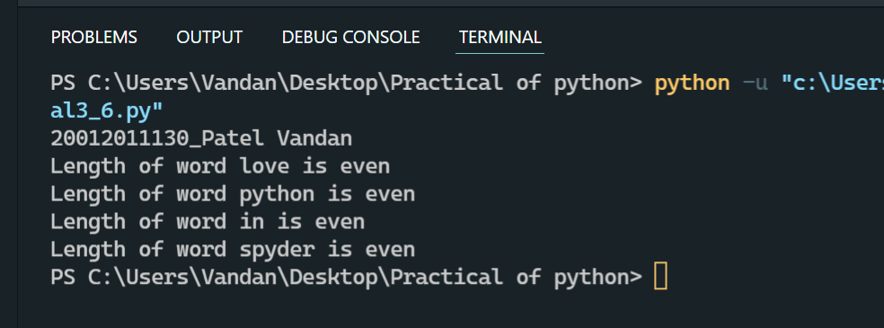

1. Write a program to count number of digits, upper-case characters and lower-case characters from the string.

**Code:**

print("20012011130_Patel Vandan")

st = input("Enter statement:")

upper,lower,digit,special=0,0,0,0

*for* i *in* st:

*if*(i>='A' and i<='Z'):

        upper+=1

*elif*(i>='a' and i<='z'):

        lower+=1

*elif*(i>='0' and i<='9'):

        digit+=1

*else*:

        special+=1

print("Uperercase count=",upper)

print("Lowercase count=",lower)

print("diditcase count=",digit)

print("specialcase count=",special)

**Output:**

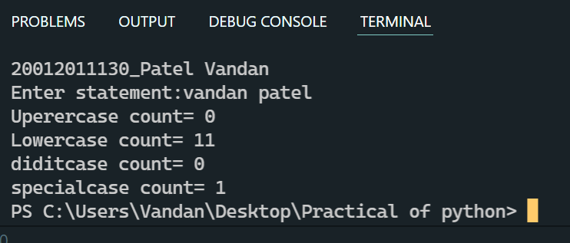

1. Write a python program to check if a string is a palindrome or not.

**Code:**

print("20012011130_Patel Vandan")

str1 ='hello'

str2 =''

*for* i *in* str1:

    str2 = str2 + i

*if*(str1 == str2):

    print(f"{str1} is a palindrome string.")

*else*:

    print(f"{str1} is a palindrome not string.")

**Output:**

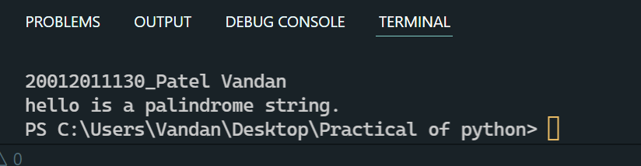

1. Write a python program to remove i’th character from string.

**Code:**

print("20012011130_Patel Vandan")

st = 'hello'

i=1

st=st[0:i]+st[i+1:]

print(st)

**Output:**

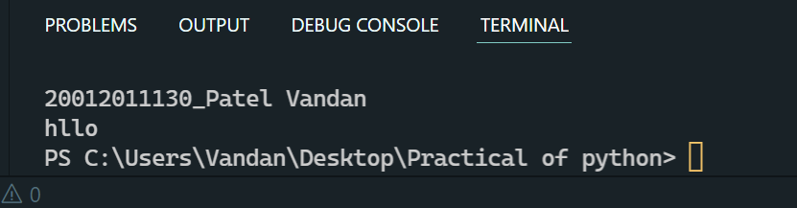

1. Write a python program to check if the substring is present in a given string.

**Code:**

print("20012011130_Patel Vandan")

expression="I am Student of Ganpat University"

print("Expression : ",expression)

str= "Ganpat"

print("present in expression : ",str *in* expression)

**Output:**

